My professor's feedback:

" I see what you are trying to do and there is an argument that diversity impacts literacy. I feel that you are getting closer to illustrating that point but at the moment it is not there.

In your introduction you have no clear claim that connects literacy to issues of language diversity. What methods can actually improve writing and reading with diversity in mind. You do say that instructors knowing another language may create bonds with their students but that does not provide specific details about how this improve skills such as reading comprehension or writing skills in a new language. These types of details are needed to connect these two ideas together and need to be bolstered with further research.

In addition you seem to summarize your research in the results section but do not provide enough analysis of these finding in the discussion. This section is the moment where you can possibly connect even further diversity with literacy by introducing other scholars work that connects these two and analyzing it to make the case as how a diversity conscious classroom can help with literacy.

Please also look at my comments on your paper as well.

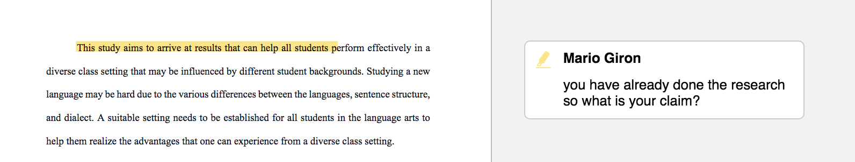

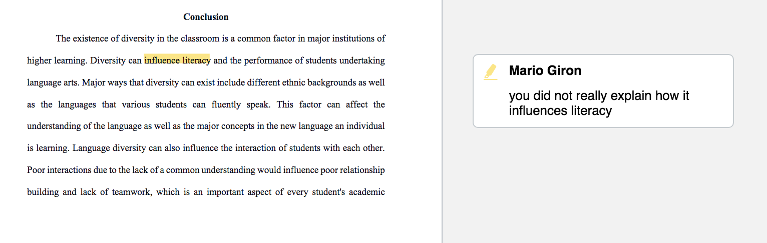

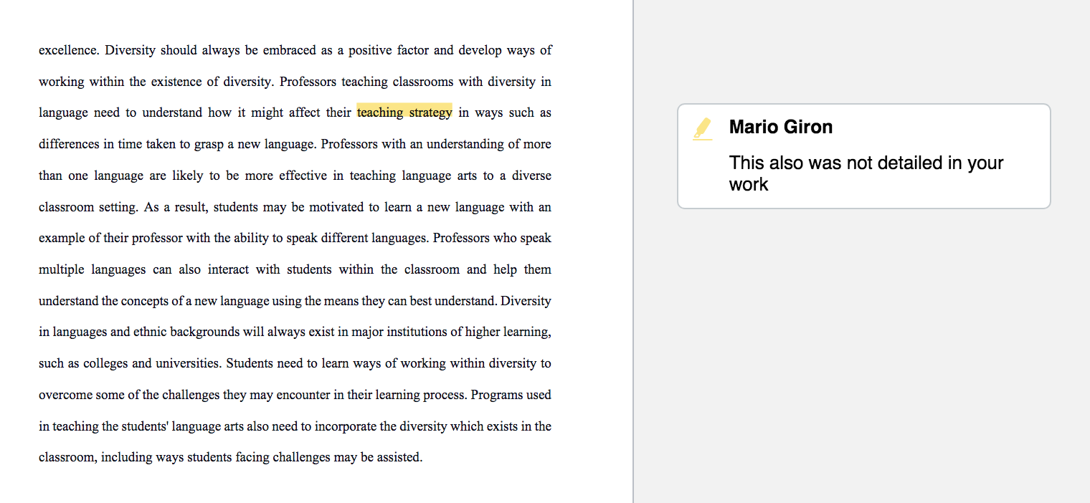

Doing these actions will help your paper truly answer what the prompt is asking of you “

It might be your last revision for this project if you carefully read my professor's feedback and revise it well based on the feedback. The final bonus will reflect on the quality of this revision. Therefore, please spend more time doing this revision and changing some parts based on the feedback to make the paper better. Please be critical in the revision, dear. I will release all the payment and add good amount of final bonus if you do really really well. ALSO, FOR THIS ONE I NEED TO SUBMIT MY WORK BEFORE AND AFTER THE REVISION. THEREFORE, YOU HAVE TO DO PLENTY OF SIGNIFICANT CHANGES/ REVISIONS BECAUSE MY PROFESSOR WILL COMPARE AND SEE WHAT YOU HAVE DONE BASED ON THE FEEDBACK WHETHER YOU DO CHANGES BASED ON ALL HIS FEEDBACK OR NOT.

I hope that this revision will be the last revision that you made; therefore, please do you absolute best!

I will give you less than 48 hours to do the final revision! Please read the prompt carefully!

Use this recent work because I did revisions on some parts already:

Language arts for diverse college students: The role of teachers in promoting effective learning in the midst of diversity.

Abstract
This research paper investigates the various aspects of language arts, including learning and teaching for diverse college students. The paper investigates some of the factors driven by the diversity that influence the learning process of the language of the arts. The study also examines some of the major challenges that diversity in ethnic backgrounds, language that and individual speaks or their writing styles can affect learning arts language in a diverse classroom setting. This research paper's information was selected from a diverse set of reliable sources to know the various effects of diversity on students' learning process or the challenges diversity in the classroom brings to students due to diversity in language or writing styles. The study results were intended to enlighten the professors on some of the possible effects of diversity on the students and the problems the students may face while studying arts language in the diverse classroom setting. Recommendations are also offered on the various ways a favorable environment can be created to enable the students who speak different languages to study arts language easily.

Introduction
Diversity in the classroom setting in the current society is a major factor. Major learning institutions, including universities and colleges, admit different students to their institution. The students may have differences in culture, race, language, religion, beliefs, as well as major differences in language. When all the students meet in the classroom, there is a wide diversity created within the classroom, including differences in language. Diversity within learning institutions and in the classroom is a major factor as it brings people with different beliefs together as well as students with different learning abilities. Although diversity is an important factor within colleges and universities, diversity in the different languages spoken by students may affect students' academic performance, especially those studying the language of arts in different colleges (Ogbu, 2017).
Language diversity has a major influence on the learning process in diverse classroom settings, with major challenges that international students face. Students are affected by differences in cultures, language, and beliefs and may affect their participation in different classroom tasks. Learning language arts in the midst of language diversity can be challenging for some students who may feel that they don't belong and may tend to exclude themselves from other native speakers. Some students may also experience difficulty catching up with others when they have a problem with learning the new language (Delpit, 2015).
The colleges and professors teaching language arts in a classroom with language diversity can develop various ways of improving student interactions within the classroom in order to ensure all students in language arts can progress well together regardless of their native language. This can reduce the possible problems that arise from failing to embrace diversity (Delpit, 2015).
The professors teaching diverse classroom have a role of assessing the needs and challenges faced by different students to identify the best reading or writing resources which can help in solving their problem. Professors can use diversity as a way of bringing different literacy concepts from different resources and to the classroom and sharing them. This study aims to arrive at results that can help all students perform effectively in a diverse class setting that may be influenced by different student backgrounds. Studying a new language may be hard due to the various differences between the languages, sentence structure, and dialect. A suitable setting needs to be established for all students in the language arts to help them realize the advantages that one can experience from a diverse class setting (Boyd, et al,2016).
Methods
Different secondary sources were deemed helpful in conducting this research. Various articles relating to language diversity and literacy were used in gathering information to support the study hypothesis. The validity of the sources used in this study was ensured by selecting the sources that explain the effects of language diversity on the general process of learning. Helpful secondary sources from reliable authors helped in gathering substantial evidence on the research topic. Secondary resources from authors such as Margi Gottlieb explain that although the student backgrounds' differences may bring differences in language within the classroom, students can easily learn a new language with fluency effectively when their professors apply various strategies (Boyd, et al,2016).
The different sources used in this research also help in expressing different opinions from different authors on ways of embracing diversity in learning institutions and effectively teaching language arts to a diverse set of students. However, the articles and sources express similarity in their arguments regarding some of the strategies helpful in promoting effective learning amid diversity. For instance, many authors agree that the attributes of the professor or the teacher of the new language may be one of the important aspects in setting up an effective learning environment for the students with differences in language as well as creating programs that address some of the anticipated issues in the classroom. An English subject teacher, Lois Matz, who is also the director of learning at the Thompson Centre, is one of the most reliable authors one can get how teachers can effectively influence their classroom to progress together when learning a new language regardless of the background (Rosen, &Abt-Perkins, 2016).
The authors offer various recommendations on how teachers can implement the most effective strategies to help them embrace the diversity in the languages spoken by the students in their classrooms. The secondary sources offer various information on how students can be influenced to easily grasp the basic concepts in language arts regardless of their backgrounds and level of knowledge. The professor's role in promoting literacy, without being limited by the existence of diversity in language or even the writing styles of the students, can also help improve the academic performance of their students (Boyd, et al, 2016).

Results
One of the major types of diversity which may exist in the classroom due to the differences in student backgrounds and cultures, as explained by Margi Gottleib, includes differences in language and writing styles. Different aspects of the learning process are influenced by the diversity which exists in the classroom. A classroom setting characterized by differences in ethnic backgrounds that promotes language differences also experiences low student interactions among each other due to the lack of a common language of communication. Students are likely to choose their peers based on the ability to communicate; hence students forming more relationships with the students they can share a common language. Diversity can have various effects on the process of learning for the language arts students when introduced to a new language making students' understanding of the newly introduced language also differ. Methods of offering support to individuals who experience challenges in learning a new language are important in improving literacy in a classroom with language diversity. Support programs can also help the students improve in other sectors such as communication with their peers as well as ease in understanding other subjects taught in the same language (Gottlieb, & Ernst-Slavit, 2013).
Margi Gottlieb offers various recommendations of the various ways schools can play a role in improving the learning process and reducing the challenges that students may face when introduced to a new language within the classroom. The provision of support resources by the school is an important factor to help the students learn a new language effectively. Establishing a set of language standards for the classroom as well as the whole school would also be important in promoting ease of learning the new language when students can learn more as they communicate with each other using the new language. Margi Gottlieb promotes the professors’ importance of reflecting on their teaching programs and their techniques, which evaluates them to establish their effectiveness and help find an alternative to the programs that do not work. The diversity existing within the classroom should always be a major factor to consider by the language professors as it may influence their interaction with the students, which influences literacy.
Rosen and Abt-Perkins (2016) explain some of the professors' individual factors, which may influence the learning process of different students in the classroom. The professors who get to teach a new language to a classroom where language diversity is a major character should always consider these factors. An example is the professor's background. The background of the professor influences their language and their fluency in the new language. It also influences the professor's understanding of the differences that may exist within the classroom setting, including the languages spoken by their students. Students taught by professors who depict and understanding various languages are likely to be highly motivated to learn the language with their professor as a major example. The socio-economic status of the professors also influences their ability to learn different languages. Various studies conducted recently show an increase in the number of people seeking to improve their literacy through language arts and learning of a new language. This increases the number of job vacancies for professors of different languages. The main challenge is that many of the middle economic class individuals are likely to be monolingual in English. This way, the teachers may find it hard to relate with the students in the classroom as the teacher of a new language does not understand the student's languages. Most especially, they cannot easily sympathize with them. The professors lacking a proper understanding of their students' cultures may also find it hard to establish meaningful interactions with their students required to promote efficiency in the learning process (Rosen, &Abt-Perkins, 2016).
The authors offer other recommendations on the importance of the relationships maintained by the teachers and the students. The relationships are considered as a major way of joining forces between the subject professors and their students to promote efficiency in understanding the new language. As new students enroll for the different classes, the professors can establish various relationships that help them share resources to address the growing literacy needs. The resources are also important for the students in learning the new language. In a diverse classroom setting, students learning a new language should always select and form relationships with the individuals who understand the new language instead of sticking with individuals who share the same background. In general, maintaining relationships between teachers and their students or students with fellow students can promote efficiency in the learning process even when diversity in language is considered a primary challenge (Boyd, et al,2016).

Discussion
Diversity exists in various institutions. According to the study, language diversity is likely to be a major factor contributed by different student backgrounds or ethnicity. In a classroom with diversity in language, the students are likely to take different times to develop a fundamental understanding of the concepts shared through a language different from their native language. There are probable to be significant differences in dialect or the understanding of ideas in different languages. Diversity in language arts may also be witnessed by the student’s ability to read and write in a different language. Different languages also influence students’ ability to interact with each other and form relationships that can help with their academic excellence. The diversity influenced by students speaking different languages can lead to various challenges to students undertaking language arts. Moreover, students’ ability to understand a newly introduced language can differ greatly, making some students perform better than others in classwork. Teamwork is also a major factor when there are differences among the students as it can help support students experiencing any challenges in understanding the new language. This may also be challenged by the differences in ethnic backgrounds, which can lead to different languages and writing styles. Students may take a longer time to build any productive relationship with other individuals with who they don’t share a language with (Rosen, &Abt-Perkins, 2016).
Multilingual professors can have an added advantage when teaching a diverse classroom setting. The professors can easily interact and communicate with their students using different languages inside and outside the classroom. Through these interactions, the professors can explain the various concepts learned in a new language in the best way the student can understand (Rosen, &Abt-Perkins, 2016). The professors can also get to understand each of the student’s challenges and the best way to help them. When the professors have a good understanding of their classroom, they can also help the students in forming groups which can bring significant improvement in one another (Boyd, et al,2016).
Students may also have different challenges in reading and writing in a new language. As students may come from different backgrounds, their ability to read and write or grasp the new concepts learned in the classroom may vary. Various reading materials can be provided to help the students in grasping the concepts in the best way possible. Some examples of languages which may exist within a classroom may include Spanish, Chinese, French, Swahili and even Korean. Students with the different backgrounds may require different resources which explain the new concepts in their language. Students should be encouraged to interact with each other and share the various ideas they learn from the different resources. When the professors can understand the different languages, they can also help the students when they encounter any challenges when reading the various resources. With the different resources, they can help in solving some of the reading and writing problems influenced by diversity and also use diversity as way of bringing different understanding of the same concepts in classroom. When the diverse students interact to share the different concepts learned in the language they can best understand, they can also improve each other’s understanding if the concepts (Rosen, &Abt-Perkins, 2016).
Conclusion
The existence of diversity in the classroom is a common factor in major institutions of higher learning. It influences the use of different study materials and resources which explain various concepts in a language that the student can easily understand. When the students read the different concepts in different languages, they can bring them together in the classroom and share them with each other. This can bring a significant improvement and in each of the student’s progress with the syllabus. Diversity can influence literacy and the performance of students undertaking language arts. Major ways that diversity can exist include different ethnic backgrounds as well as the languages that various students can fluently speak. This factor can affect the understanding of the language as well as the major concepts in the new language an individual is learning. Language diversity can also influence the interaction of students with each other (Delpit, 2015). Poor interactions due to the lack of a common understanding would influence poor relationship building and lack of teamwork, which is an important aspect of every student's academic excellence. Diversity should always be embraced as a positive factor and develop ways of working within the existence of diversity. Professors teaching classrooms with diversity in language need to understand how it might affect their teaching strategy in ways such as differences in time taken to grasp a new language. Professors with an understanding of more than one language are likely to be more effective in teaching language arts to a diverse classroom setting. As a result, students may be motivated to learn a new language with an example of their professor with the ability to speak different languages. Professors who speak multiple languages can also interact with students within the classroom and help them understand the concepts of a new language using the means they can best understand. Diversity in languages and ethnic backgrounds will always exist in major institutions of higher learning, such as colleges and universities. Students need to learn ways of working within diversity to overcome some of the challenges they may encounter in their learning process. Programs used in teaching the students' language arts also need to incorporate the diversity which exists in the classroom, including ways students facing challenges may be assisted (Delpit, 2015).

References
Delpit, L. D. (2015). 16 Language Diversity and Learning. REPORT NO ISBN-0-8141-3524-2 PUB DATE 90 NOTE 304p. AVAILABLE FROM National Council of Teachers of Rd., Urbana, IL 61801 (Stock No., 247.
Ogbu, J. U. (2017). Understanding cultural diversity and learning. Educational researcher, 21(8), 5-14.
Boyd, F. B., Ariail, M., Williams, R., Jocson, K., Sachs, G. T., McNeal, K., ... & Morrell, E. (2016). Real teaching for real diversity: Preparing English language arts teachers for 21st-century classrooms. English Education, 38(4), 329-350.
Gottlieb, M., & Ernst-Slavit, G. (2013). Academic language in diverse classrooms: English language arts, grades K-2: Promoting content and language learning. Corwin Press.
Rosen, L. M., &Abt-Perkins, D. (2016). Preparing English teachers to teach diverse student populations: Beliefs, challenges, proposals for change. English Education, 32(4), 251-266.

